Project Doc

Abstract
This project is an Election Voting System designed to conduct a simple election through a console interface. The program allows the user to enter the number and names of candidates, start the voting process, and cast votes by selecting the corresponding candidate number. It stores the votes using arrays and calculates the candidate who receives the highest number of votes. Finally, the program displays the vote count of each candidate and announces the winner.
The project is useful for students, beginners learning Java, and small-scale voting demonstrations where a simple method of collecting and counting votes is required. It demonstrates important Java concepts such as arrays, loops, methods, user input using Scanner, conditional statements, and basic data processing.

Advantages
- Simple and Easy to Use – The program uses a straightforward console interface, making it easy for users to enter candidates and cast votes.
- Automatic Vote Counting – Votes are automatically stored and counted by the program, reducing the need for manual counting.
- Demonstrates Important Java Concepts – The project makes practical use of arrays, methods, loops, conditional statements, and the Scanner class, making it useful as a learning project for Java students.
- Quickly Determines the Winner – After voting is completed, the program compares the vote counts and identifies the candidate with the highest number of votes.

Implementation Details [The Code]:
import java.util.Scanner;
class Project{
static Scanner in = new Scanner(System.in);
static int findIndex(int arr[],int t){
if(arr==null)
return -1;
for(int i=0;i<arr.length;i++){
if(arr[i]==t)
return i;
}
return -1;
}
static String inputs(String prompt){
System.out.print(prompt);
String a = in.nextLine();
return a;
}
static void clearScreen() {
System.out.print("\033[H\033[2J");
System.out.flush();
}
static int inputi(String prompt){
System.out.print(prompt);
int a = in.nextInt();
in.nextLine();
return a;
}
public static void main(String[] args){
clearScreen();
int n = inputi("How many candidates are there ? ");
String [] can_list = new String[n];
int [] votes = new int[n];
clearScreen();
for(int i=0;i<n;i++){
System.out.printf("Enter Candidate %d :",i+1);
can_list[i] = inputs(" ");
clearScreen();
}
while(true){
char svote = inputs("Start voteing (Y/N) : ").charAt(0);
clearScreen();
if(svote == 'Y'){
break;
}
}
while(true){
for(int i=0;i<n;i++){
System.out.printf("Candidate %d %s\n",i+1,can_list[i]);
}
int vote = inputi("Enter your canditate number : ")-1;
clearScreen();
if(vote<0){
break;
}
votes[vote]++;
}
for(int i=0;i<n;i++){
System.out.printf("%s %d \n",can_list[i],votes[i]);
}
int c=0;
for(int i=0;i<n-1;i++){
int a = votes[i];
int b = votes[i+1];
if(a>b && a>c){
c=a;
}
else if(b>c){
c=b;
}
}
String winner = can_list[findIndex(votes, c)];
System.out.print(winner+" has won the election!!!!");
}
}

Output Screenshots:
Entering number of candidates:
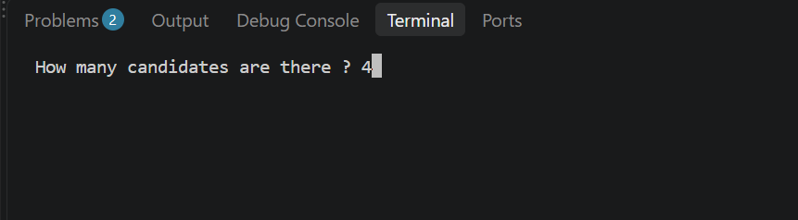
Entering candidate names: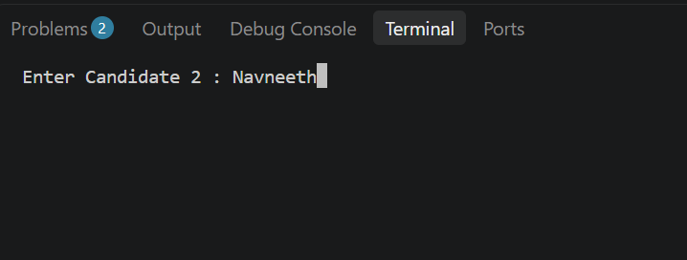
Starting the election:
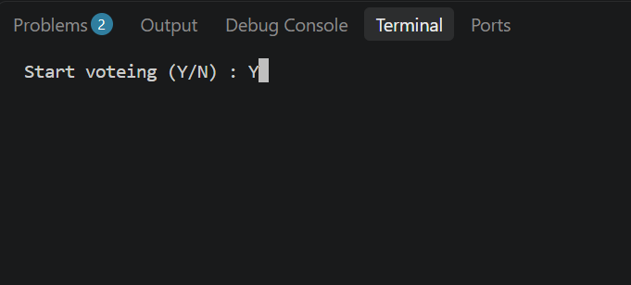
Voting interface:
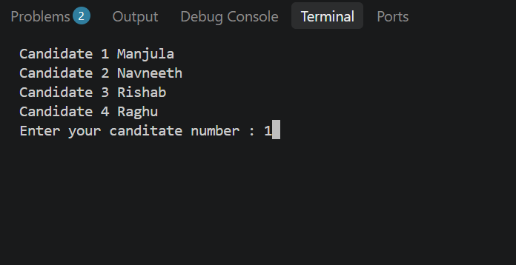
Entering 0 in voting terminal to end the election:
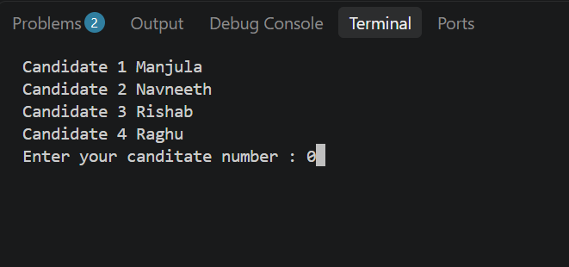
The election result screen:
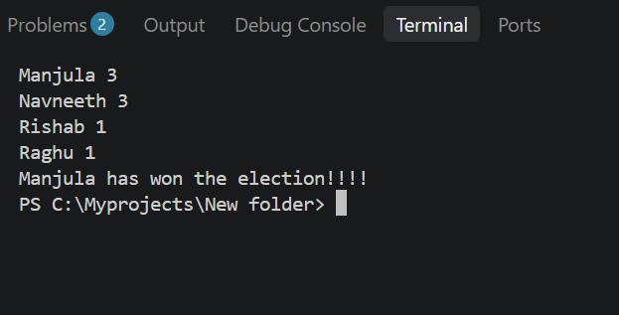

Conclusion
In conclusion, the Election Voting System provides a simple way to conduct and manage a basic election through a console-based program. It successfully allows candidates to be entered, votes to be collected and counted, and the winning candidate to be displayed. The project is particularly useful for understanding how Java can be used to solve real-world problems using basic programming concepts. Although it is designed for a simple demonstration rather than a large-scale election, it provides a good foundation for developing more advanced voting systems in the future.

